# Task 1 – RC Circuit

## 1

Components and Values: DC Voltage 2.2 Volts, 3.3 nF capacitor, and 44.2 kohms resistor.

Figure 1- RC Circuit Design

Figure 2 - Voltage across Capacitor in RC Circuit

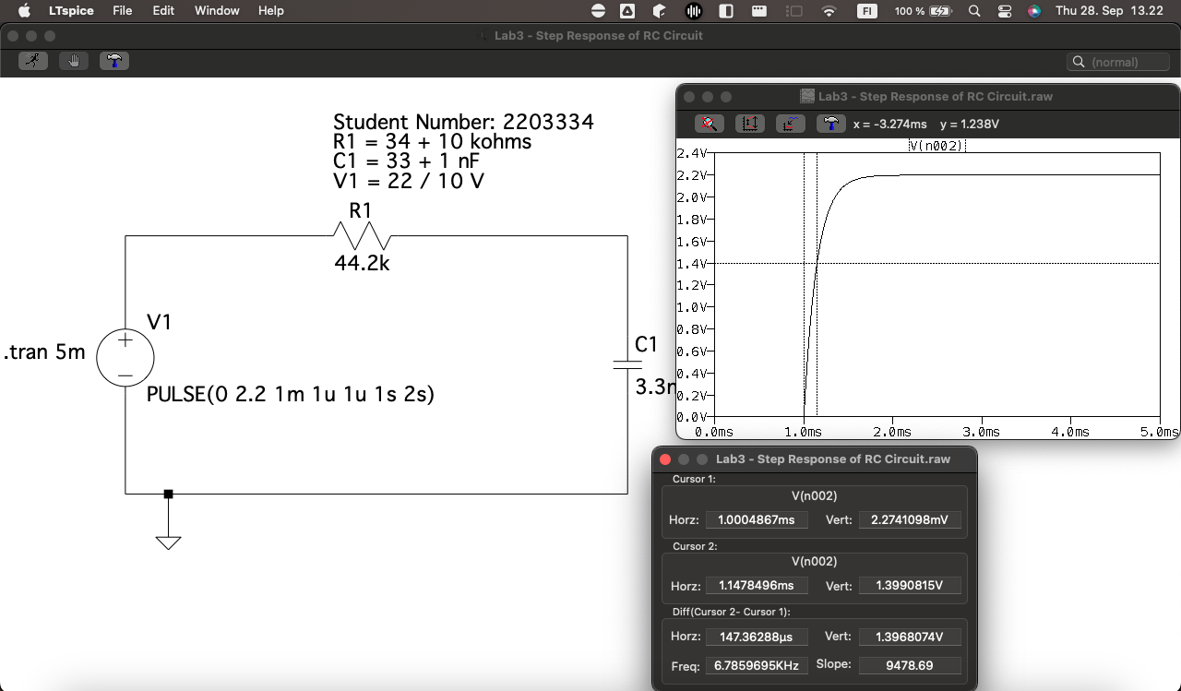

Half time from the step response = 147.36288 micro second based on the graph above

R = 44.2k ohms (or 44.2 x 10^3 ohms)

C = 3.3nF (or 3.3 x 10^−9F)

Τ = (44.2x10^3) × (3.3x10^−9)

Τ ≈ 146 microseconds

# Task 2 – RL Circuit

Components and Variables: DC Voltage 2.2 Volts, 4uH inductor, and 40.2 ohm resistor.

Figure 3 - RL Circuit Design

Figure 4 - Current across Inductor in RL Circuit

Half time from the step response = 786.94712 nano second based on the graph above

R = 40.2 ohms

L = 4uH (or 4 x 10^−6H)

T = L / R

Τ = (4x10^−6) / 40.2

Τ ≈ 99.5 nanoseconds

Figure 5 - Voltage vs Current across Inductor in RL Circuit

# Conclusion:

In the series of experiments conducted on both RC and RL circuits subjected to a step input, we observed consistent principles governing their transient responses, although the underlying physical phenomena differ.

**RC Circuit:**

The transient behavior of the RC circuit was governed by the charging of the capacitor. The time constant T=RC quantified how quickly the capacitor charges. Specifically, in a time span of T, the voltage across the capacitor reached approximately 63.2% of its final value in response to a step input.

For our specific RC circuit with component values R = 44.2k ohms and C = 3.3nF, we computed a theoretical time constant of approximately 146µs. This would be the time taken for the capacitor voltage to rise to about 63.2% of its eventual steady-state value due to a step voltage input.

**RL Circuit:**

The RL circuit's transient behavior was determined by the inductor resisting a change in current. The time constant T = L / R described how rapidly the current through the inductor reaches its steady-state value. Similar to the RC circuit, in a time frame of T, the current (or the voltage across the resistor) reached approximately 63.2% of its final steady-state value in response to a step input.

For our specific RL circuit with components R = 40.2 ohms and L = 4µH, the calculated time constant was approximately 99.5ns. Thus, in this duration, the current through the inductor (or voltage across the resistor) would rise to about 63.2% of its final value due to a step voltage input.

In an RL circuit with a step voltage input, the voltage across the inductor is characterized by its transient and steady-state behavior.

Transient Behavior:

Immediately after the step voltage is applied, the inductor opposes any change in current, and therefore, the voltage across the inductor spikes to the magnitude of the applied step voltage. This is because the inductor tries to maintain the current at its initial value (which is zero if starting from rest), causing a rapid change in voltage across it.

Steady-State Behavior:

As time progresses, the current through the inductor increases and approaches its steady-state value. Consequently, the voltage across the inductor decreases. When the circuit reaches steady-state (after a long enough time), the voltage across the inductor becomes zero. This is because an ideal inductor acts as a short circuit to DC currents in steady state

From both experiments, it's evident that the time constant plays a crucial role in determining the speed of the response of first-order systems like RC and RL circuits to sudden changes in input. Furthermore, by knowing the values of resistance and either capacitance or inductance, we can predictably determine the transient behavior of these circuits. The experiments reinforce the utility of the time constant as a key metric in understanding and predicting circuit responses to abrupt changes.